Here are codes for several things. Remember you need to use < at the very beginning and > at the very end.
to add music, but where you see my ID and song name, yours will need to go there:
EMBED src=http://www.geocities.com/kathisavon/newyear.mid hidden=true type=audio/midi autostart="true" loop="3" volume="65%"
To align text or picture: P align= after the = you will need to put center, left or right
to add a picture you want: IMG src="http://www.geocities.com/kathisavon/flaming.gif" width=340 height=25 (again remember you picture/ID and picture name go in place of mine.
To add scrolling: MARQUEE direction=(what ever direction you want, up, down, left, or right) scrollAmount=2 scrollDelay=5
Another thing to remember every time you want something to end you need to add the /
/font /strong /marquee /p
to add a link to your site for customers to browse without registering first you will need this code, but remember to mention on your website that registration is required to order online,: IMG src="http://www.youravon.com/images/catalog/2006/01/p1.jpg" width=245 height=350 (this is picture code) A href="http://www.youravon.com/catalog/2006/01/index.html" (this is link code) so to get your page to look like:
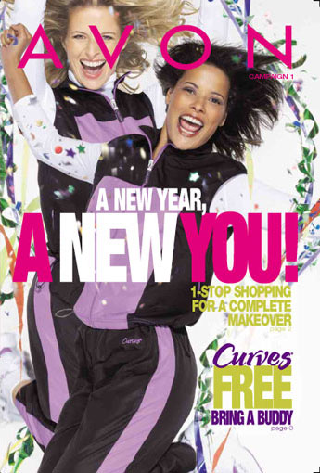
Starting a New Year Campaign 01
You need your code to look like this: (p align=center)(IMG src="http://www.youravon.com/images/catalog/2006/01/p1.jpg" width=245 height=350)(/P)(/FONT) (P align=center)(A href="http://www.youravon.com/catalog/2006/01/index.html")(FONT color=#ff0000 size=3)(STRONG)(EM)Starting a New Year Campaign 01(/EM)(/STRONG)(/FONT)(/A)(/P) Of course replacing all the ( with < and all the ) with >
I hope this helps a lot of you out and you don't have to go searching post's to find the codes.
Kathi

