This is the snap shot using Firefox

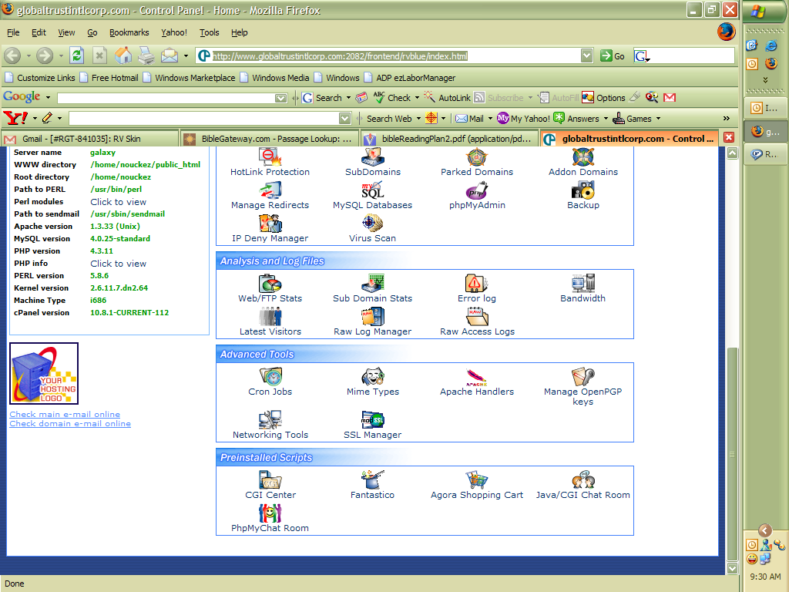

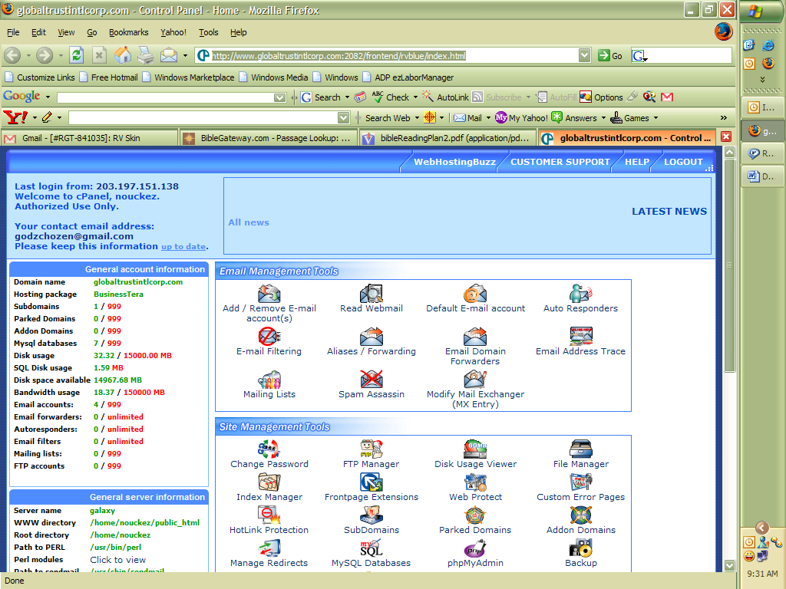

Thinking that it may be the browser, this is the snapshot using IE

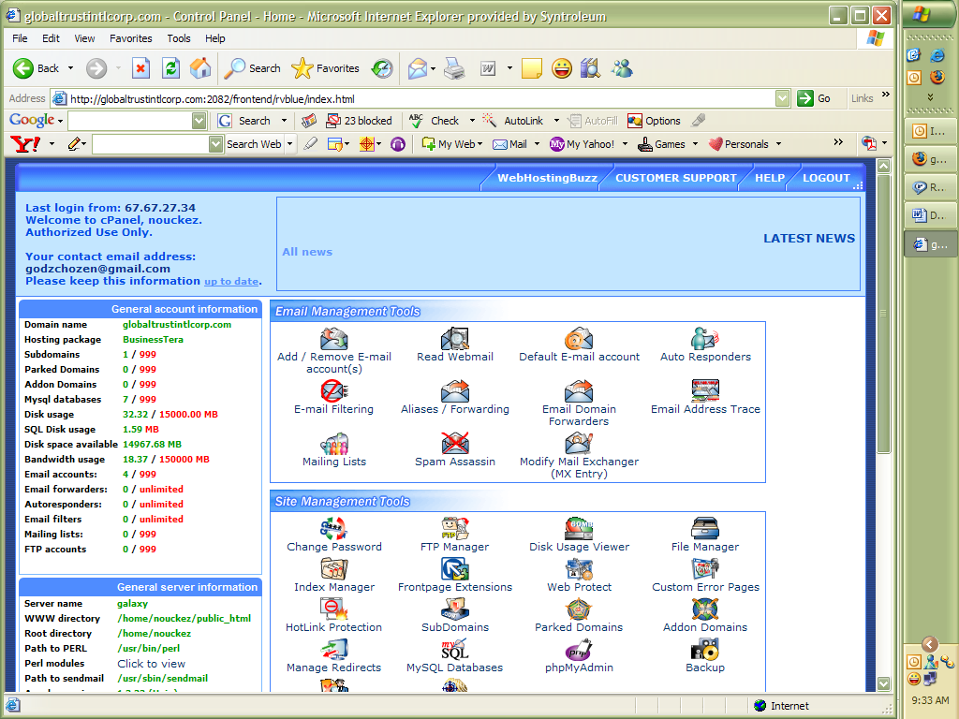

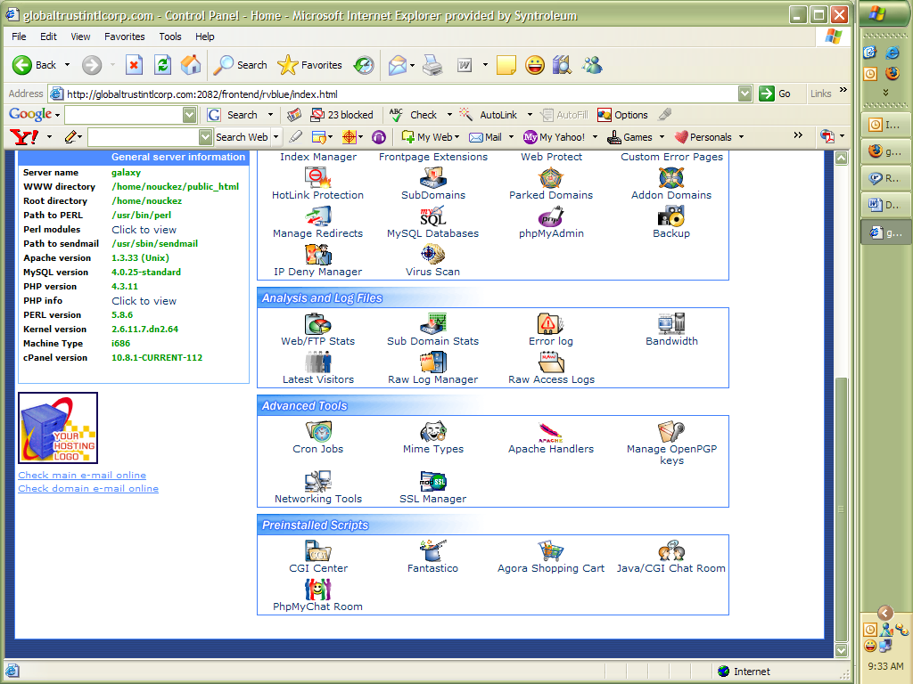

As you can see the option for languages does not show up anywhere.

Thank you.

